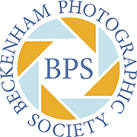
BPS NEWS BULLETIN
Issue No 24: March 2025

Annual Exhibition Shows Off Members’ Original and Creative Work
Beckenham yet again scored a great success with its 2025 exhibition. More than 200 visitors came to view our work including Beckenham and Penge MP Liam Conlon are well underway. Members entered 95 prints and 63 digital images which impressed judge Eddie Hyde FRPS. He described the breadth of high-quality images as “extensive” and said there was a great deal of “originality and creativity” on display.

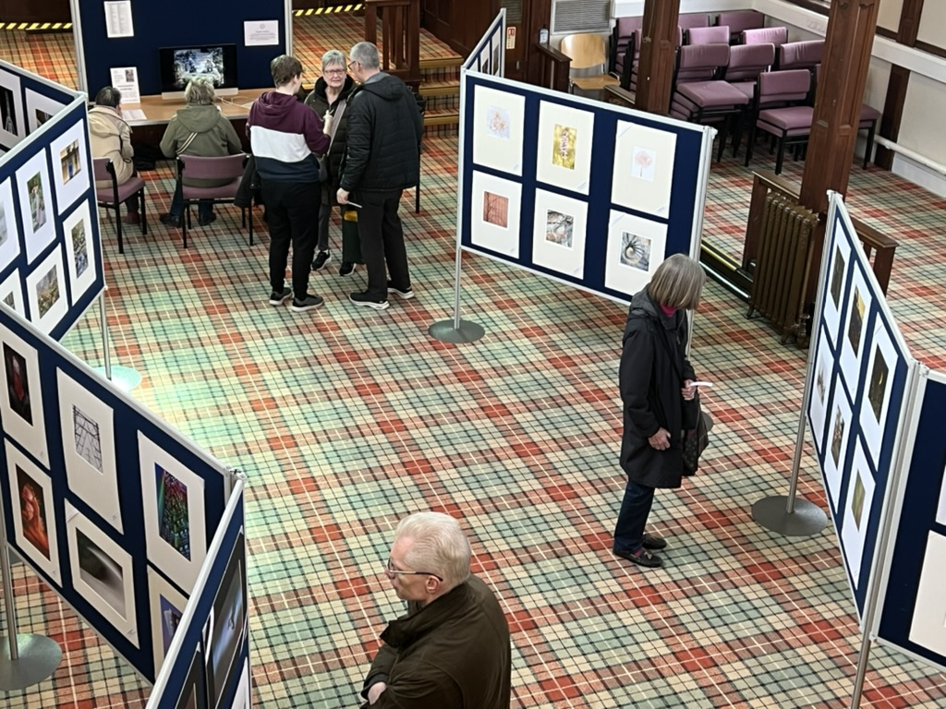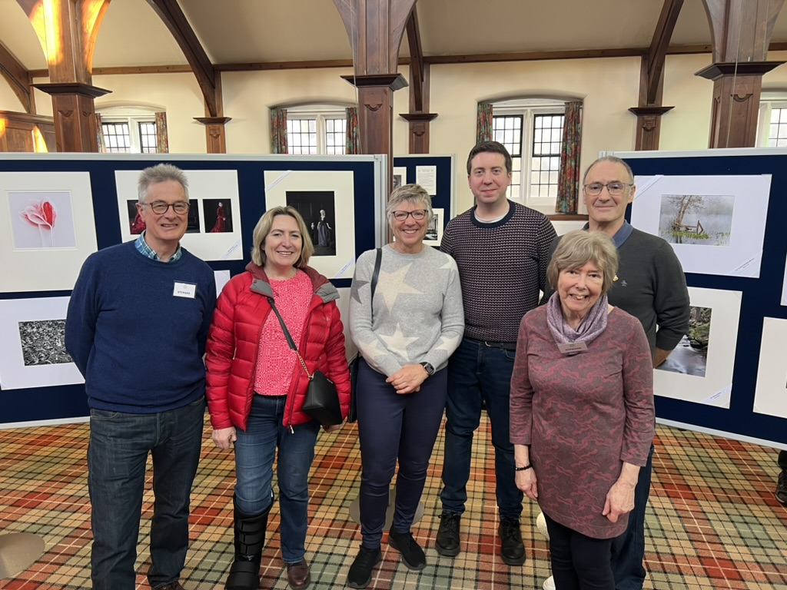

Visitors to the exhibition were encouraged to vote for their favourite print and digital image and their votes were widely cast 189 were registered for the prints and 154 for the projected images.

We can now announce the winners of the 2025 People’s Choice. Sharing first place in the exhibited prints section was Barrie Brown with his image Glasswing and Carole Dowd with her Family of Mycena; both achieving 10 votes. In the digital section, Angela Ford swept first and second places with her images Into the Light (20 votes) and Tree of Light (10 votes). Thank you to everyone who voted.

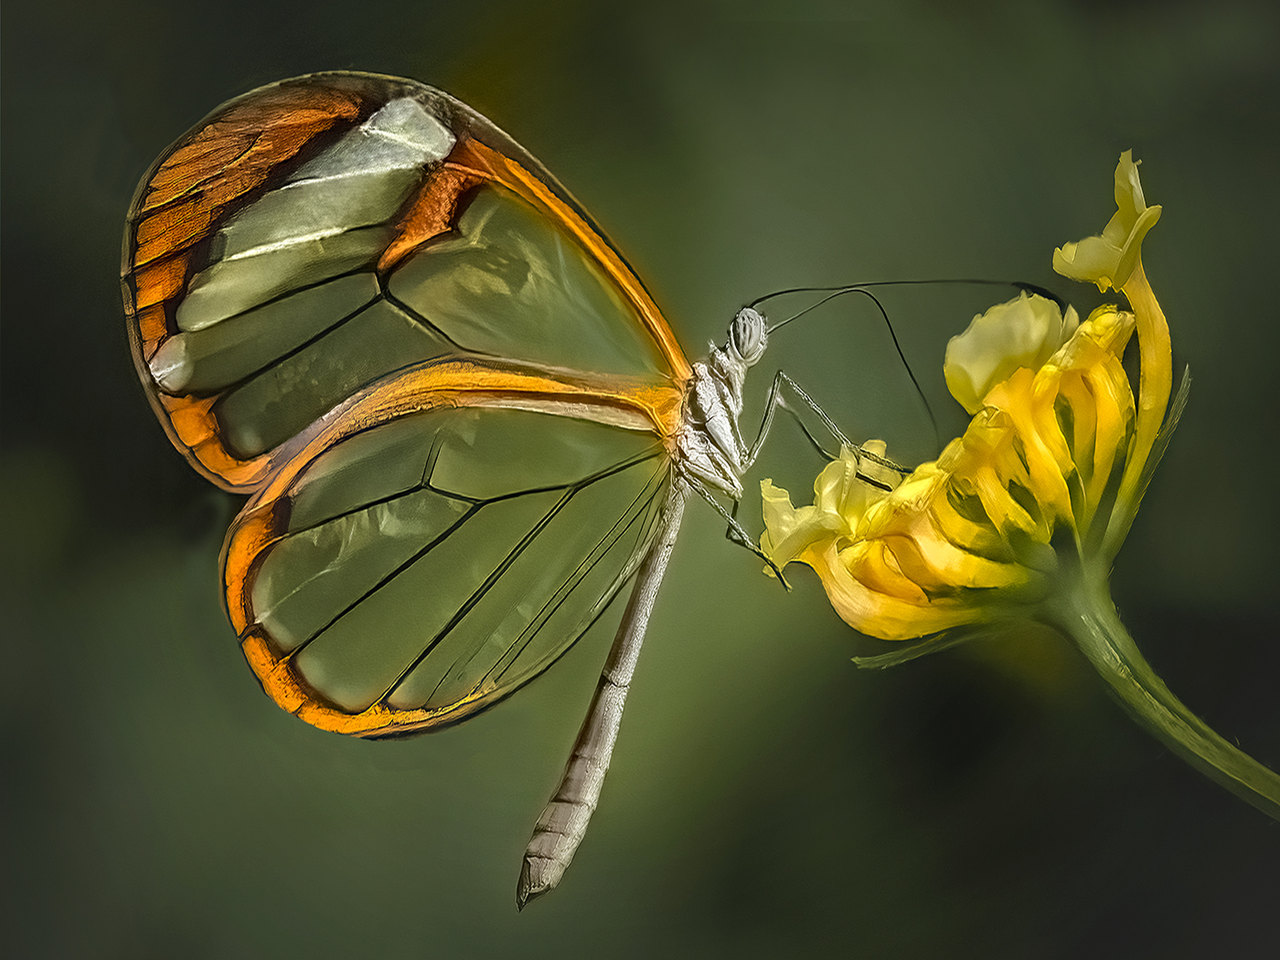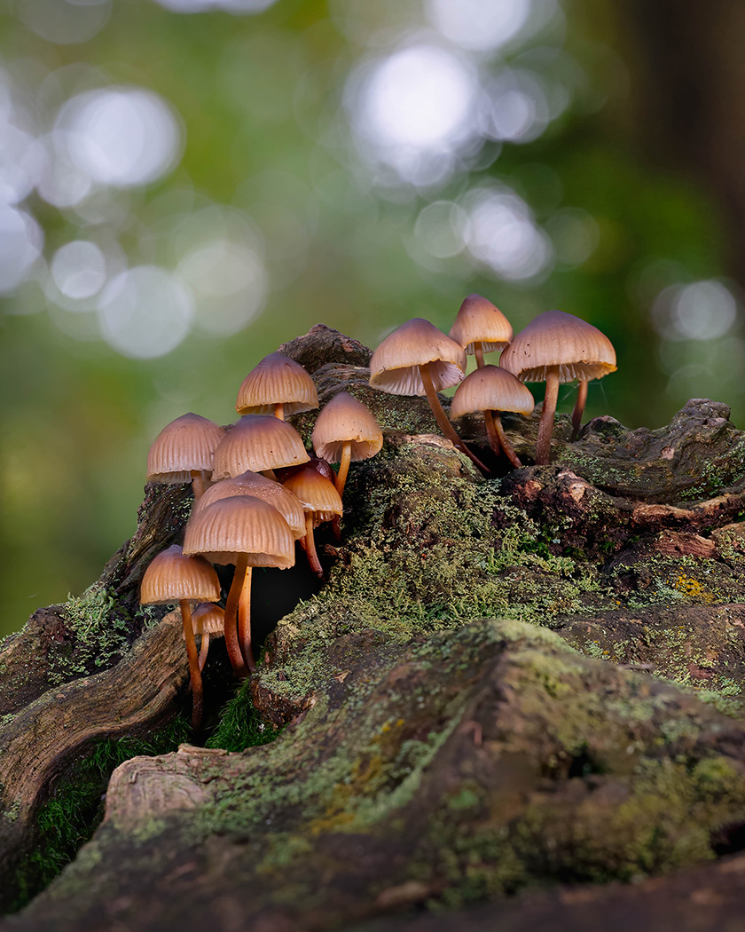
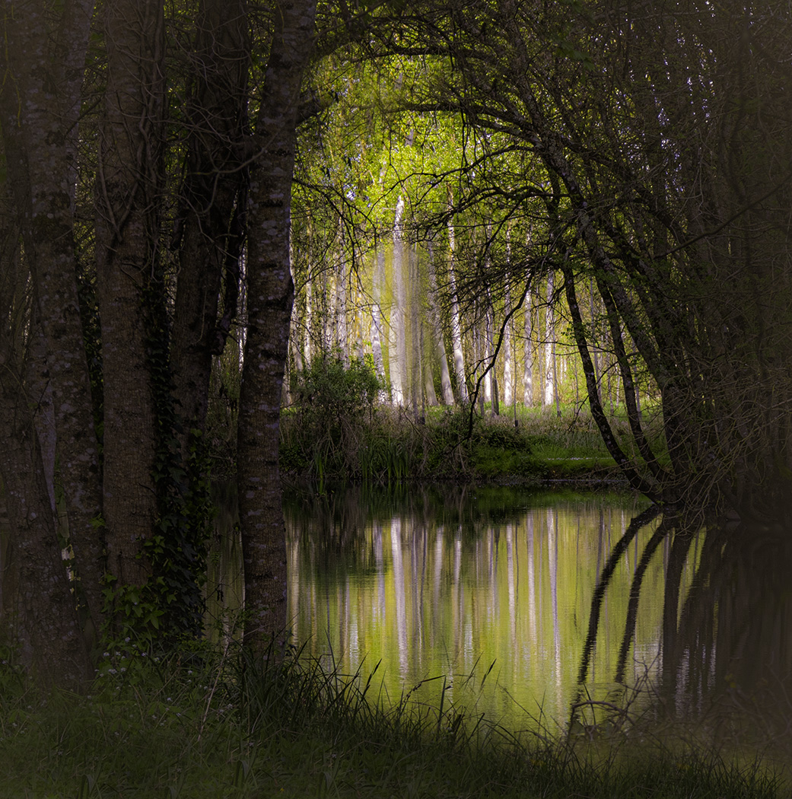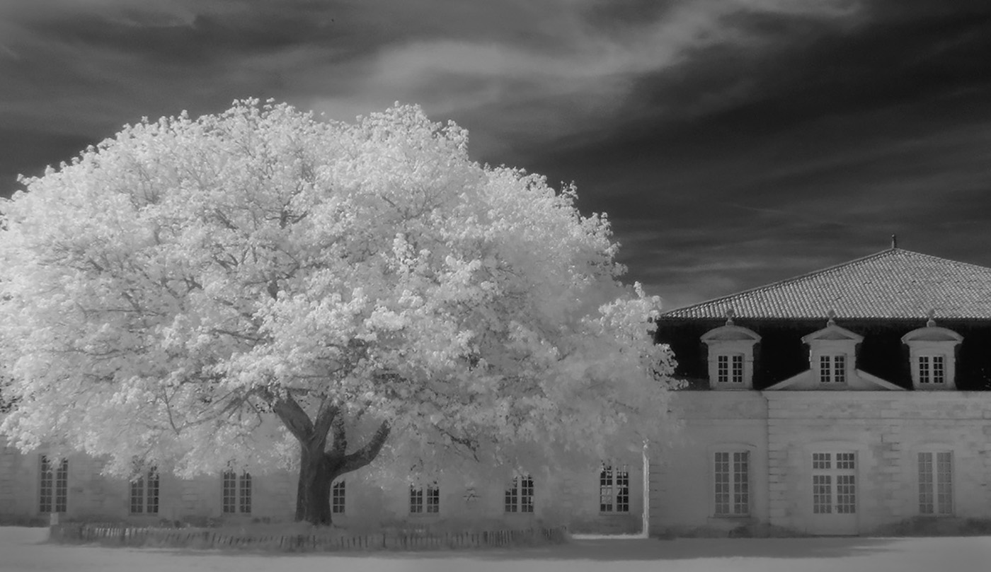

BPS will soon be enjoying a community exhibition with a selection of prints displayed at the deli/café at 94 Wickham Road, Beckenham BR3 6QH, near the Chinese Roundabout and Kelsey Park. The show will run from March 31st until April 21st.

Stock up on Mount Board Now

At the end of March, Lesley Rees will make another bulk order for mount board from Cotswold Mounts. As the Wideangle Market no longer carries any stocks, please make sure you take this opportunity to buy your boards with no minimum order amount (usually £20 + VAT) and sharing the delivery cost of £9. A small margin is added for BPS funds. The next BPS order is not likely to be until October/November.

Mount boards are available in packs of 4 in standard 40x50cm size, ready for you to cut your own aperture, and in white or cream core. White core is archival quality and costs a little more than cream core. Cotswold Mounts can also cut apertures to your specific requirements in packs of 4 same-size apertures only. These are more expensive but may be worth it if you have difficulty cutting your own. Various sizes of pre-cut backing boards (plain or self-adhesive) are available in packs, or you can buy an A1 sheet of lightweight backing to cut your own. Adhesive tape and presentation bags are also available.

Please email Lesley (lesleyrees@btinternet.com) with details of your order no later than Wednesday 24 March. Please state number of packs and colour - don’t just say ‘white’ as there are lots of different whites! - and whether white core or cream core, as well as any backing, tape and bags you require. Cotswold Mounts’ website gives details of colours for camera club boards ( https://www.cotswoldmounts.co.uk/product-category/backing-boards/ ) and information on other products. Please don’t hesitate to ask Lesley in person or by email if you have any queries.

Call for Entries for London Salon of Photography

Entries are now open for this year’s London Salon of Photography. This is a prestigious exhibition which will tour the country and will be hanging in The Camera Club in London SE1 4DS between 11th August and 5th September.

Salon member Roger Ford is urging BPS members to put forward images that meets its aim of exhibiting “that class of photographic work in which there is distinct evidence of artistic feeling and execution”. He says: “Having seen the BPS exhibition, there are a number of members who are producing work that fits this definition and may be interested in entering.

The online entry is now open with details on the website https://thelondonsalon.org/. Members can view images from previous salons there as a guide to what is likely to be successful. Prints can either be posted to arrive before 13th April or delivered before 26th April. Roger will be taking his entry to Smethwick on 25th April and is happy to take other members prints with him.

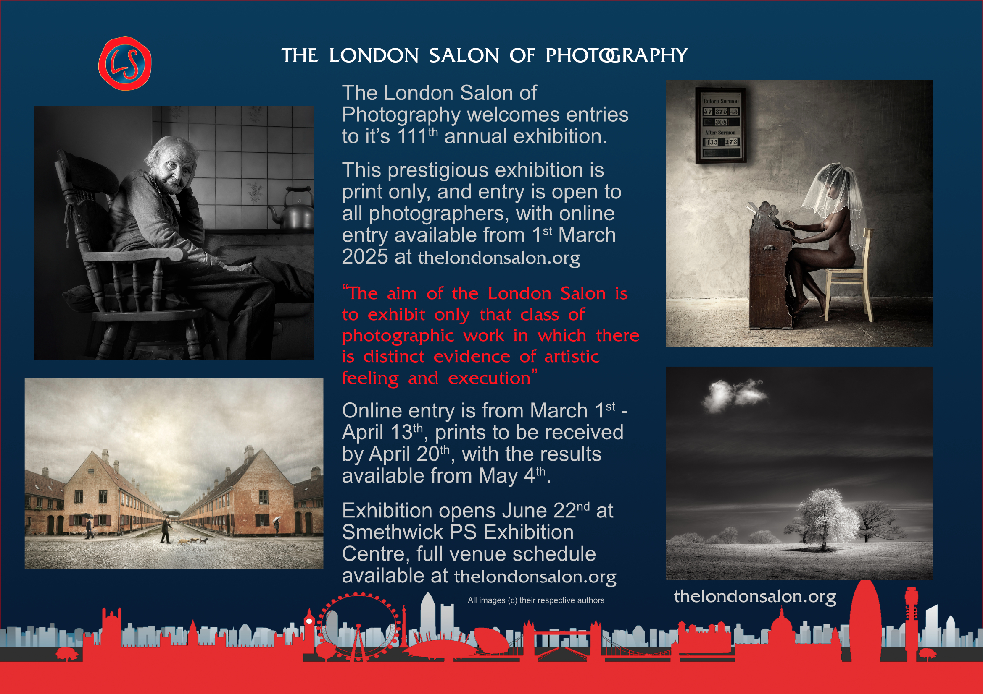

Catch Members’ images at Spectrum Photo Art Exhibition

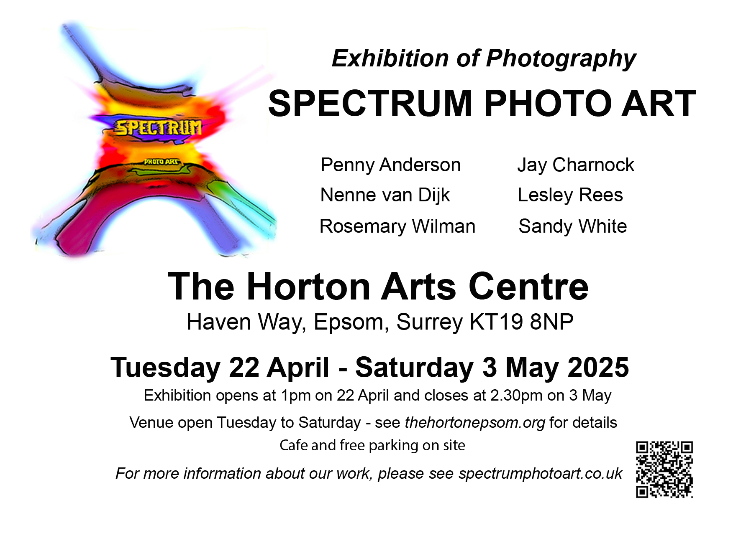

Spectrum Photo Art group - which includes BPS members Nenne, Sandy and Lesley - is holding an exhibition in the Horton Arts Centre, Haven Way, Epsom, KT19 8NP from Tuesday 22 April (opens 1pm) to Saturday 3 May (closes 2.30pm). The six photographers will be exhibiting around 100 prints in a variety of styles. Horton Arts Centre opens from Tuesday to Saturday and has free parking and a cafe. Please check its website (thehortonepsom.org) for opening hours and other details.

Oh, we do Like to be Beside the Seaside

Former BPS member Jackie Andrews has kindly offered to lead a Margate photo walk on Saturday May 3rd. Margate is always a great location for street and beach photography and there will be an opportunity to visit Resistance, the current exhibition at the Turner Contemporary Museum which focuses on how protest shaped Britain and photography shaped protest.

The plan will be to meet at Margate station at 10.25 or even take the 8.57 train with other members from Bromley South. More information to follow but save the date now.
Events for Your Diary

RPS London Regional Members’ Print Exhibition will run from March 26th to March 30th at The Espacio Gallery 159 Bethnal Green Road London E2 7DG. The gallery is open from 11am to 6pm (closes 4pm on Sunday 30th), with an open view on the Thursday evening from 6.30pm. In total 115 RPS members each have a print and digital image on view including BPS members Angela and Roger Ford, David and Lesley Rees, Keith Surey, Sheree Dodd, Fred Barrington and David Pollard.
Until 18th May the National Portrait Gallery is featuring The Face Magazine: Culture Shift showing over 200 photographs from the magazine that 2004 played a major role in creating contemporary culture. https://www.npg.org.uk/whatson/exhibitions/2025/face-magazine/
The V&A has now finished adding galleries to its photography exhibition space making it the largest permanent photography exhibition in the UK. It includes the RPS Collection.
The 80s: Photographing Britain is a very successful exhibition currently at Tate Britain. It explores the role of photography in a decade of social and political change. Look out for news of a BPS visit to the exhibition in either February or March. For more details see https://www.tate.org.uk/whats-on/tate-britain/the-80s-photographing-britain.
The Photographers' Gallery has just launched new photo exhibitions including Deutsche Börse Photography Foundation Prize 2025 and a retrospective of the work of Peter Mitchell, one of the most important colour photographers of the 1970s and 1980s who has chronicled life in Leeds for more than four decades. Go to https://thephotographersgallery.org.uk/whats-on.

The Wildlife Photographer of the Year winning entries are still on display at the Natural History Museum until 29th June 2025. https://www.nhm.ac.uk/visit/exhibitions/wildlife-photographer-of-the-year.html.

The Astronomy Photographer of the Year is on at the National Maritime Museum in Greenwich until July. Admission is free while the museum is undergoing construction work.
It features over 100 images from photographers across the globe displayed on lightbox screens. See: https://www.rmg.co.uk/whats-on/astronomy-photographer-year/exhibition

THANK YOU for reading this News Bulletin. Look out for Issue No 24 in early May. It is really appreciated if you can contribute articles, feedback, images, news items, suggestions, advice, announcements. Please send to beckenhampscomms@gmail.com. Deadline for copy for the next issue is midday on 30th April.

